|  |  |
| --- | --- |
|  | **Year 12 *ATAR* Physics Unit 3** **2018**  ***Test 3 Moments and Equilibrium 3.0%***  **NAME: ………………………………………………….**  Data: See Data Sheet  Approx. marks shown.  ***(55 marks)*** |

When calculating numerical answers, show your working or reasoning clearly. Give final answers to **three** significant figures and include appropriate units where applicable.

When estimating numerical answers, show your working or reasoning clearly. Give final answers to a maximum of **two** significant figures and include appropriate units where applicable.

1. Explain why it is not possible for you to get up from your seat without first leaning forward. You may use diagrams to illustrate your answer. [3]

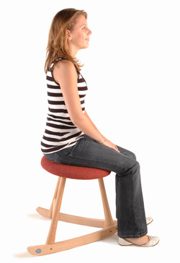

If you do not lean forward, the weight of your body [1m], acts to create an anticlockwise torque [1m] that brings your body back to the seat.

When you lean forward, the weight of your body, acts to create a clockwise torque that brings your body forward [1m] and you are able to get up from your seat.

Mention weight [1m]

Causing torque and direction of torque to move person backward. [1m]

Mention torque that allows person to move forward [1m]

2. Explain whether a water glass that tapers down to a narrow base is easier to tip over than one with straight sides. [2]

A glass that tapers down to a narrow base is easier to tip over. [1m]

This is because its centre of gravity is higher. [1m]

Discuss the difference in stability a full tapered glass and an empty tapered glass. [2]

If the tapered glass is full, its CG is raised. [1m]

It is less stable compared to an empty tapered glass. [1m]

|  |
| --- |
|  |

3. The irregular object show in the figure below hung on a string. Its centre of mass is as shown in the figure.

The object rotates to and fro till it reaches a final position.

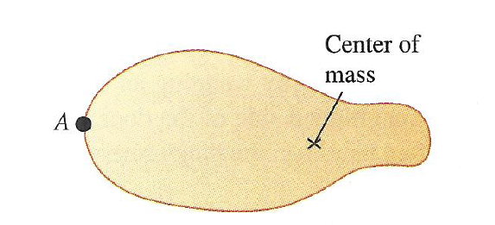

a. Explain why the object rotates to and fro. [2]

The weight of the object acting through the centre of mass creates a clockwise torque

about A. [1m]

The object rotates clockwise till the center of mass passes A vertically.

Now, the weight creates an anticlockwise torque about A to swing the object

anticlockwise. [1m]

This causes the object to rotate to and fro.

b. Friction acts to eventually stop the object from rotating. State the position of the centre of mass in the object’s final position. [1]

The object reaches its final position when the centre of mass is vertically below the pivot A.

[1m]

4. The diagram shows four forces applied to a circular object. The radius of the object is *r*. [4]

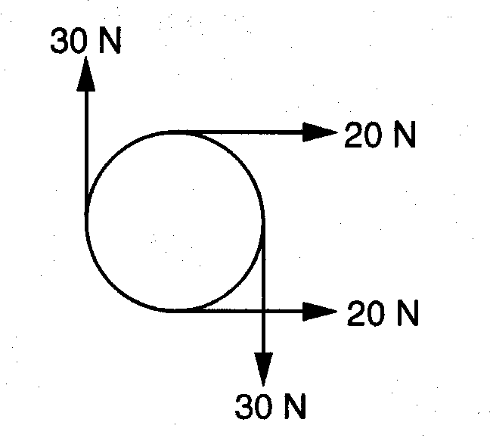

Which of the following describes the resultant force and resultant torque on the object?

Circle correct letter.

|  |  |  |
| --- | --- | --- |
|  | resultant force | resultant torque |
| **A**  **B**  **C**  **D** | zero  zero  non‑zero  **non‑zero** | zero  non‑zero  zero  **non‑zero** |

[1m]

Justify your answer by calculating the resultant torque (in terms of *r*) and the resultant force .

Resultant torque = sum of clockwise torques – sum of anticlockwise torques

= 30r + 20r - 20r [1m]

= 60r clockwise. [1m]

Resultant force = 40 N to the right [1m]

5. A globe is strung up in a classroom as shown in the diagram below. Note that the roof and T2 are both horizontal.:



If the mass of the globe is 1.20 kg, determine the tension T1 and T2. The one cable is horizontal to the ground. [4 marks]

Vertically:

[1m]

= 14.4 N [1m]

Horizontally:

[1m]

= 8.23 N [1m]

6. A cantilever 5.0 m long is shown below. It has a mass of 800 kg and is held up by two supports **X** and **Y**.

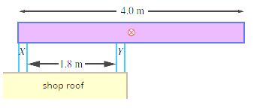

Y

X

2.2 m

5.0 m

a. State the direction of the force exerted by support **X** on the cantilever. [1]

|  |
| --- |
| It is downwards. |

b. Determine the force that each of the supports exerts on the cantilever. [4]

Take X as pivot;

clockwise torque = 800 x 9.8 x 2.5 Nm [0.5]

anticlockwise torque = FY x 2.2 Nm [0.5]

clockwise torque = anticlockwise torque

FY = 8910 N upwards [1]

Upward forces = downward forces

8910 = 800 x 9.8 + FX [1]

FX = 1070 N downwards [1]

7. Sumo wrestling is a sport with a simple objective: push your opponent so they topple over. The Sumo wrestler is often a very large person with a lot of weight. When they begin the wrestlers move their feet apart on the floor and crouch down low to the floor.

a) Explain why Sumo wrestlers stand in this way. [2]

They do this to lower their Centre of Gravity. [1m]

They also widen their base. [1m]

b) A 180 kg Sumo wrestler goes to sit 10 cm from the left end of a 250 cm long bench. The bench has a mass of 4.50 kg.

i) How far from the other end of the bench should an 80 kg spectator sit to just stop the bench from tipping if the legs of the bench are 60 cm from each end? Draw and label all forces and measurements on the diagram below. [6]

Normal reaction, FN

125 cm

d cm

125 -d cm

50

cm

Normal reaction, FN

65 cm

10

cm



**Q**

**P**

Weight of spectator, FG

= 80 x 9.8 N

Weight of bench, FG

= 4.5 x 9.8 N

Weight of sumo wrestler, FG

= 180 x 9.8 N

Forces acting as shown [1m]

When bench is tipping, normal reaction at Q = 0 N [1m]

Taking moments about P:

Sum of anticlockwise moments = [1m]

Sum of clockwise moments = (

[1m] [1m]

As sum of clockwise moments = sum of anticlockwise moments

d = 0.812 m [1m]

Answer:____________________

ii) Each leg of the bench can only withstand a maximum force of 2500N. Will the bench break with the Sumo wrestler and the spectator seated as above. Show your working out. [3]

Sum of upwards forces = sum of downward forces [1m]

Fn at P = (80 x 9.8) + (4.5 x 9.8) + (180 x 9.8) [1m]

= 2592 N

Yes it will break the bench as it exceeds 2500 N [1m]

Answer:____________________

8. The diagram below shows a side view of a laptop computer resting on an outdoor table. The mass of the base of the laptop is 1.50 kg and the mass of the screen is 600 g. They are both 22.0 cm long. There is an angle of 70.0° between the horizontal and the screen. The computer is blown over by wind.

Assume that the base and screen both have a uniform mass distribution.



d1

d2

70.0°

0.6 x 9.8 N

22.0 cm

22.0 cm

Wind Force

1.5 x 9.8 N

Calculate the minimum single equivalent wind force on the centre of the screen needed to tip the laptop over. [4]

cos(70°) = d1/ 0.11

d1 = 3.76 cm

sin(70°) = d2/0.11

d2 = 10.34 cm

[1m]

Taking moments about P:

Sum of clockwise moments = (1.5 x 9.8 x 0.11) Nm [1m]

Sum of anticlockwise moments = (0.6 x 9.8 x 0.0376) Nm + (Fwind x 0.1034) Nm

[1m]

As sum of clockwise moments = sum of anticlockwise moments

Fwind = 13.5 N in direction shown. [1m]

Answer:____________________

9. A ball is placed on different surfaces as shown in the diagrams below. [3]

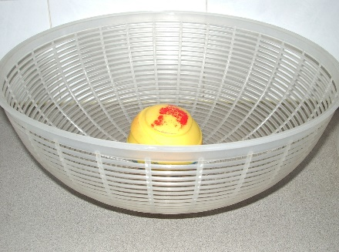 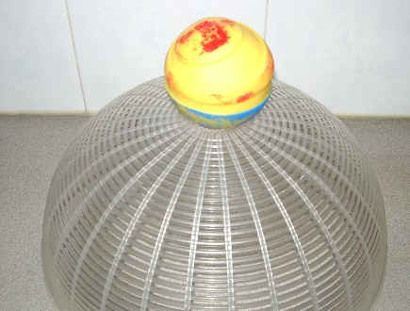 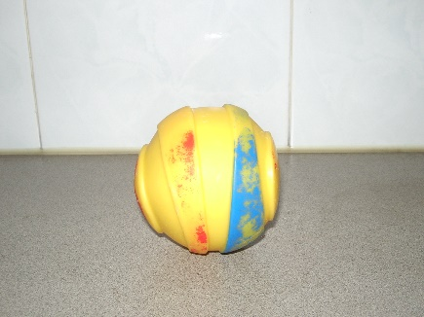

**Fig. a Fig. b Fig. c**

State whether the ball is in a state of stable equilibrium, unstable equilibrium or neutral equilibrium and explain your answer in each case.

a. Fig. a:

Stable equilibrium as it returns to its original position after an initial slight push. [1m]

b. Fig. b:

Unstable equilibrium as it does not return to its original position after an initial slight push. [1m]

c. Fig. c:

Neutral equilibrium as it remains stationary after an initial slight push.

[1]

10. A decorative mobile contains three unknown weights A, B and C. The strings and rods have negligible weight, and the rods are to hang horizontally. Find the weights of the balls A, B and C. [4]

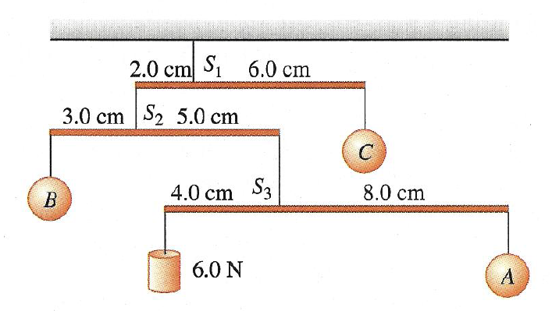

**R**

**Q**

**P**

Taking moments about P,

6.0 N x 4.0 cm = 8.0 cm x weight of A

Weight of A = 3.0 N [1]

Taking moments about Q,

Weight of B x 3.0 cm = 5.0 cm x (6.0 N + 3.0 N)

Show (6.0 N + 3.0 N) [1]

Weight of B = 15.0 N [1]

Taking moments about R

Weight of C x 6.0 cm = 2.0 cm x (15.0 N + 6.0 N + 3.0 N)

Weight of C = 8.0 N [1]

Answer:____________________

11. A person climbs a ladder that leans on wall as shown below.

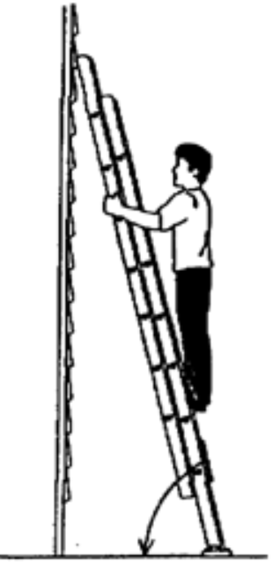

d1

3.0 m

0.5 m

**F**, Force from wall

d2

d3

**A**

1.80 m

The ladder is 3.0 m long and rests at a distance of 1.80 m away from a wall. The man stands with his feet 0.500 m above the ground. The ladder has a negligible mass, and the man has a mass of 75.0 kg.

a. Determine the angle the ladder makes with the ground. [1]

[1]

Answer:____________________

b. Calculate the force that the wall exerts on the ladder at position **A**. Assume that the force acts at right angles to the ladder. [6]

`

By Pythagoras’ Theorem,

2.4 m [1]

sum of anticlockwise moments = F x 2.40 m [1]

to find :

[1]

= 1.4246 m [1]

Sum of clockwise moments = 75 x 9.8 N x 1.4246 m [1]

As sum of clockwise moments = sum of anticlockwise moments

F x 2.40 m = 75 x 9.8 N x 1.4246 m

F = 436 N at right angles to wall [1]

Answer:____________________

c. If the person climbs higher up the ladder, explain qualitatively how the force exerted on the ladder by the wall changes. [3]

As the person climbs higher, the clockwise torque exerted by his weight is reduced. [1]

This is because the distance from the wall to his weight vector is reduced. [1]

The force providing the anticlockwise torque is reduced. [1]

Answer:____________________

**END OF PAPER**